* Procedure to create or replace new employee

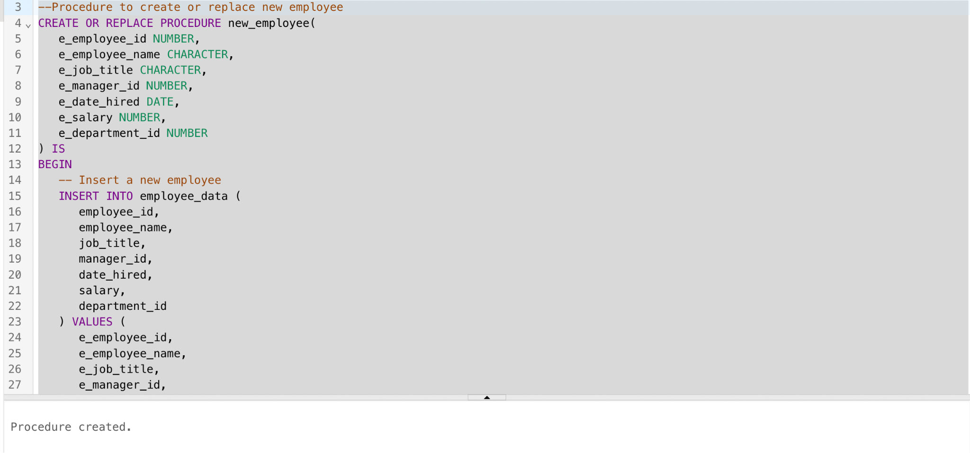

* call the above procedure with the details of new employee to be created

Employee_id ‘90020’ is created

